* **Activity 3:**

Using Table Aliases with the USING Clause

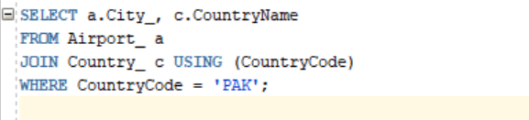

OUTPUT:

